Chapter 7 Linear motion

Chapter test Total marks 46

Name: ______________________________ Class: ____________ Date: _______________

Section A (2 marks each)

Question 1

In the study of motion, which of the following gives the best definition of displacement?

A how far a body travels

B the change in position of a body in a given direction

C the location of an object as taken from a certain direction

D the distance travelled by an object that is moving in a straight line

Question 2

In 2011, Ivo Karlovic from Croatia made the fastest recorded tennis serve in history. His serve had a speed of 251 km h–1. How fast is this in metres per second?

A 6.97 m s–1

B 69.7 m s–1

C 100 m s–1

D 904 m s–1

Question 3

A super-bouncy ball hits a wall with a velocity of 7.0 m s–1 east andrebounds with a velocity of 6.0 m s–1 west. Determinethe change in velocity of the ball.

A 1 m s–1 west

B 13 m s–1 east

C 13 m s–1 west

D 1 m s–1 east

*The following information relates to questions 4–7.*

The graph below shows the displacement of a farmer on a motorcycle, riding to and fro along a boundary of his property while counting livestock.

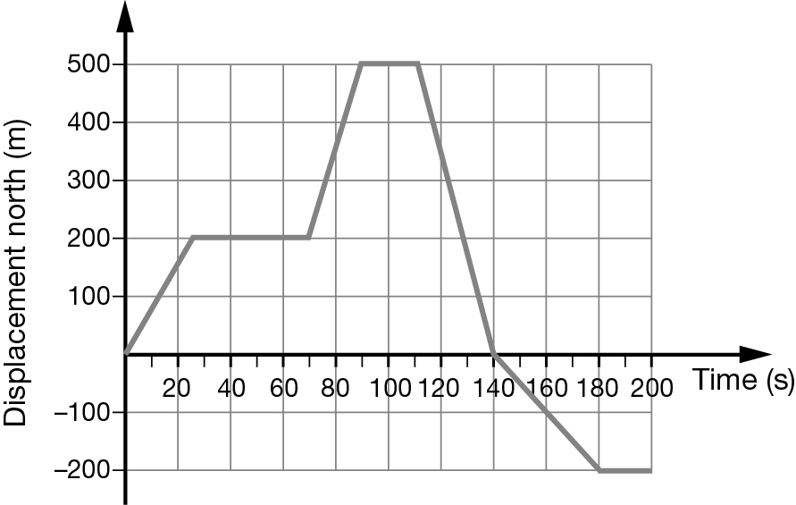

Question 4

How far did the farmer travel during the first minute?

A 60 m

B 9000 m

C 200 m

D 6.7 m

Question 5

Which of the following describes the motion of the farmer at t = 120 s?

A stationary

B heading forwards with a speed of 17 m s–1

C decelerating

D returning back with a speed of 17 m s–1

Question 6

What was the total distance travelled by the farmer over the entire period?

A 500 m

B 300 m

C 700 m

D 1200 m

Question 7

What was the average velocity of the farmer during the last 60 s of his journey?

**A** south 3.3 m s–1

**B** south 4.0 m s–1

**C** 0 m s–1

**D** south 18 m s–1

Question 8

A ball rolls down a ramp with uniform acceleration. It starts from rest and is travelling at 0.8 m s–1 when it reaches the bottom of the ramp 5 s later. Which equation should be used to determine its acceleration?

A

B 

C 

D 

Section B

Question 9

A car reaches a speed of 72 km h–1, from rest, in a time interval of 5.0 s.

a What was the average acceleration of the car in metres per second? (2 marks)

b The car then maintains this speed for 15 s. How far is it from its starting position at the end of the 15 s? (3 marks)

c The car now decelerates uniformly at a rate of 4.0 m s–2, until it comes to a stop. On the axes provided, draw the velocity–time graph for the car’s entire journey. (3 marks)

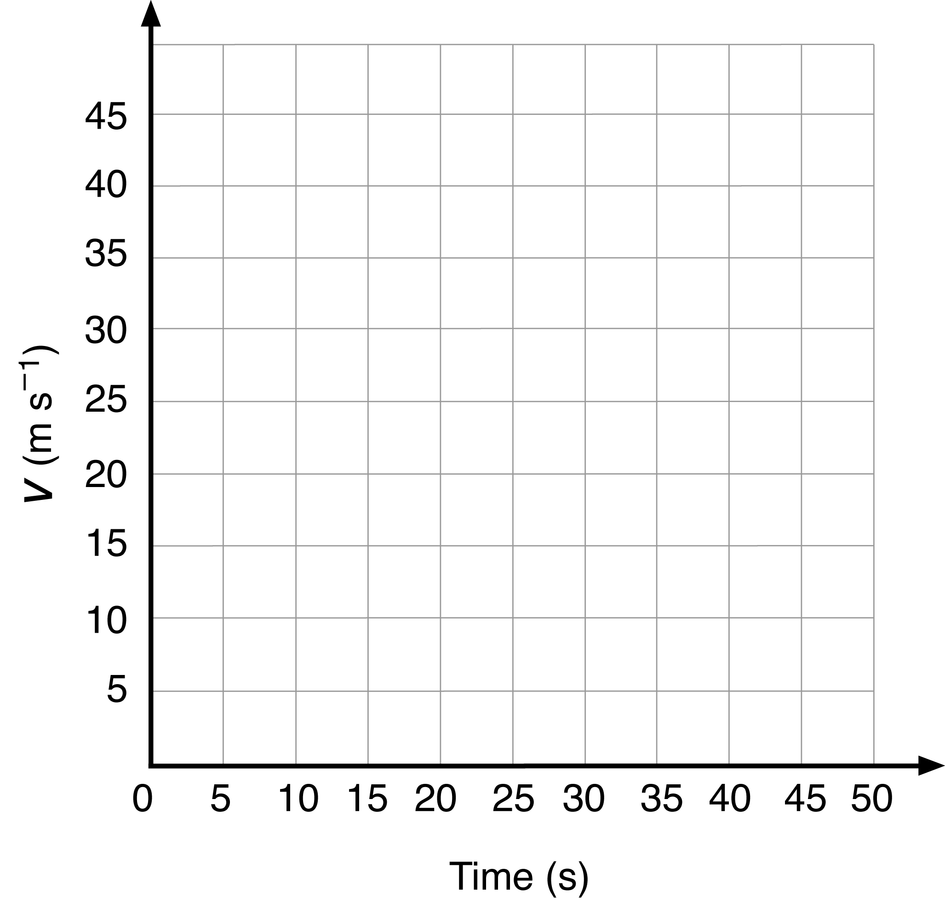

d Calculate the average velocity of the car during its entire journey. (2 marks)

Question 10

A cyclist rides 1.50 km east along a straight path at 27.0 km h−1 before she suddenly notices a ‘path closed’ sign ahead, causing her to stop.

a What is the cyclist’s initial speed in m s−1? (1 marks)

**b** If she takes 0.590 s to react to the sign, what distance does she travel before braking? (2 marks)

**c** Once she pulls on her brakes, the cyclist decelerates at 2.50 m s−2. How far does she travel while coming to rest? (2 marks)

**d** What total distance does the cyclist travel from the time she first notices the ‘path closed’ sign to when she comes to a stop? (1 mark)

Question 11

An archer fires an arrow vertically into the air from ground level at a speed of 20.0 m s–1. Ignore the effects of air resistance.

a What is the initial vertical acceleration of the arrow? (1 mark)

b For how long will the arrow be in the air? (2 marks)

c What is the acceleration of the arrow at the top of its flight? (1 mark)

d What is the maximum height the arrow will reach? (2 marks)

e What is the speed of the arrow just before it hits the ground? (1 mark)

Question 12

A stone is thrown upwards at 30.0 m s–1 from the top of a cliff and lands in the sea 40.0 m below. Ignore the effects of air resistance.

a Calculate the speed of the stone when it hits the sea below. (3 marks)

b Determine the total time the stone was moving in the air. (2 marks)

c How far above the sea did the stone reach? (2 marks)